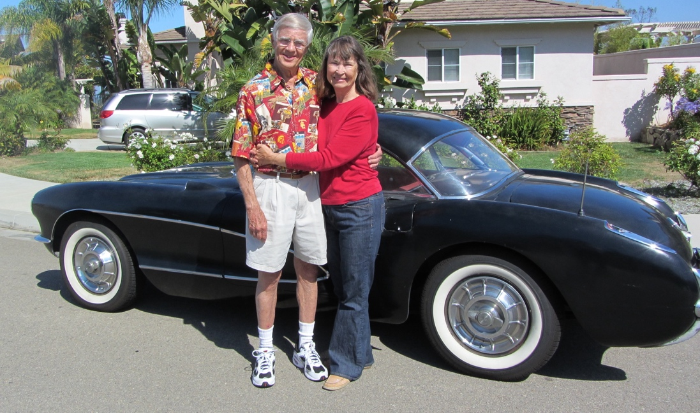

Bill & Marylyn Hatch of Carlsbad and their original 1957 Corvette

Background:
On August 12, 1957, at the age of 25 years old, Bill Hatch purchased a new 1957 Corvette
from Bates Chevrolet in Arcadia, California.

Bill married his sweetheart, Marylyn, on June 22, 1962 and they went on their honeymoon
in the Corvette. They have been married for 64 years. Bill and Marylyn moved to Carlsbad,
California in 1970 and have lived here for 56 years.

On August 12, 2026, 94-year-old Bill will have continuously owned his 1957 Corvette for
exactly 69 years. The car has been consistently registered in the State of California since
new, driven regularly, never stored, and never restored. The car is a true “survivor” with the
original engine, drive train, body, interior and almost all the component parts.

The Guinness World Record:
There is a Guinness World Record (GWR) for “Longest Ownership of a Vehicle from
New”. The current record is 67 years, 314 days. North Coast Vettes (NCV) has applied to
the Guinness World Record (GWR) to break the current record. Our application was
approved on February 7, 2026. GWR has strict requirements for creating an “event” to
establish the new record and to document all the facts.

The event is scheduled and will essentially be a “birthday party for the original owner of a
Corvette that is 69 years old”!

Event Description:
The North Coast Vettes Corvette Club, located in Carlsbad, California, will be hosting a
“Birthday Party for a 1957 Corvette” and GWR record-smashing event at The Shoppes at
Carlsbad on August 12, 2026 from 3:00 to 5:00 PM in the parking lot on the west end of the
shopping center.

The event will be attended by Bill and Marylyn Hatch, their family, and their 69-year-old
Corvette, along with the members of North Coast Vettes, the Mayor and council members
of the City of Carlsbad, a few other local Corvette Clubs, and other members of the
Carlsbad community who are interested in this special event.

We will have a DJ (with a microphone and speakers – for a few speeches), photo
opportunities and a birthday cake. There will be no vendors, and nothing for sale.

